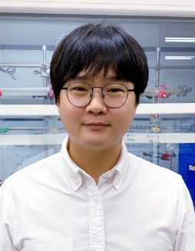
Seung Hwan Cho

Professor
Department of Chemistry, POSTECH, Pohang 37673, South Korea
E-mail: seunghwan@postech.ac.kr
Homepage: http://chogroup.postech.ac.kr

Scientific Vita
Since 2014 Assistant/Associate/Full Professor, Department of Chemistry, POSTECH
2012-2014 Postdoctoral Fellow, UC Berkeley, USA
2011 PhD, KAIST, South Korea
2006 BS, KAIST, South Korea

Research Interests
Transition-metal-free reaction
Stereoselective chemical synthesis
Organometallic chemistry

Representative Publications
- Han, S.; Lee, Y.; Seo, J.; Lee, J.; Cho, S. H. [1,3]-Hydride Shift in α-Boryl Cations: Strategic Design of Fluorine-triggered Cyclopropanation. J. Am. Chem. Soc. 2025, 147, 25910.
- Jo, W.; Thangsrikeattigun, C.; Ryu, C.; Han, S.; Oh, C.; Baik, M.-H.; Cho, S. H. Regiodivergent Alkylation of Pyridines: Alkyllithium Clusters Direct Chemical Reactivity. J. Am. Chem. Soc. 2025, 147, 8597.
- Kim, M.; Kim, G.; Kim, D.; Cho, S. H. Copper-Catalyzed Regio-, Diastereo- and Enantioselective Allylic Alkylation with 1,1-Diborylalkanes. J. Am. Chem. Soc. 2024, 146, 34861.
- Jin, Y.; Lee, J.; Jo, W.; Yu, J.; Cho, S. H. Axially Chiral α-Boryl-Homoallenyl Boronic Esters as Versatile Toolbox for Accessing Centrally and Axially Chiral Molecules. Nat. Commun. 2024, 15, 9239.
- Jung, Y.; Yoo, S. Y.; Jin, Y.; Yu, J.; Han, S.; Yu, J.; Park, Y.; Cho, S. H. Iridium-Catalyzed Chemo-, Diastereo-, and Enantioselective Allyl–Allyl Coupling: Accessing All Four Stereoisomers of (E)-1-Boryl-Substituted 1,5-Dienes by Chirality Pairing. Angew. Chem. Int. Ed. 2023, 143, e202218794.
1,1-Diborylalkanes: Versatile Reagents for Selective Bond Formation
Seung Hwan Cho
Department of Chemistry, POSTECH, Pohang 37673, South Korea
E-mail: seunghwan@postech.ac.kr

Chemo- and stereoselective transformations of polyborylalkanes provide efficient access to optically active molecules of greater complexity and diversity through programmed synthetic design.¹ Among them, gem-diboryl compounds have emerged as particularly versatile synthetic handles. Their unique advantage lies in the ability to generate two distinct intermediates, α-borylalkyl anions and gem-diborylalkyl anions, which can engage in diverse transformations to rapidly deliver a wide range of organoboron compounds. These intermediates, in turn, serve as gateways to synthetically valuable molecules. In this presentation, I will highlight our recent efforts in designing and synthesizing new gem-diboryl compounds and applying them to highly chemo- and stereoselective transformations.²⁻⁴

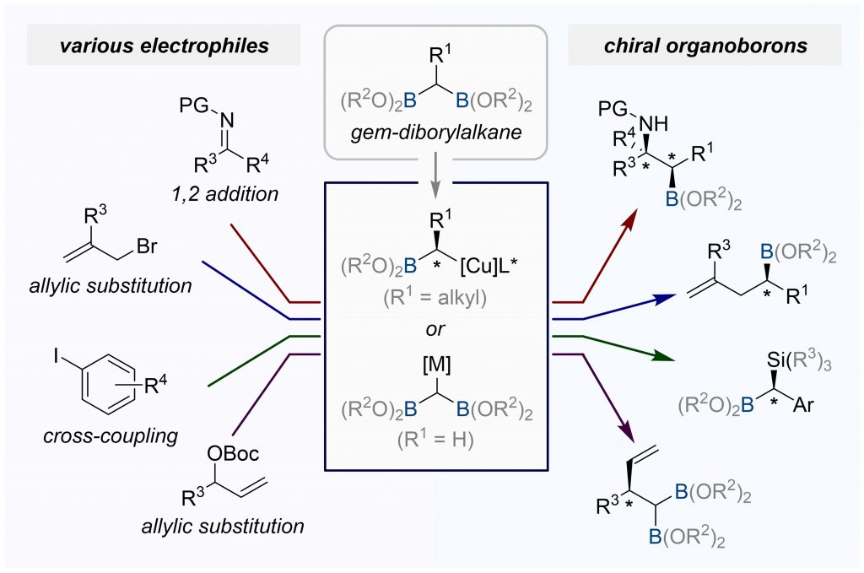
Scheme 1. Selective bond forming reactions using 1,1-diborylalkanes

References
- Lee, Y.; Han, S.; Cho, S. H. Acc. Chem. Res. 2021, 54, 3917.
- Han, S.; Lee, Y.; Seo, J.; Lee, J.; Cho, S. H. J. Am. Chem. Soc. 2025, 147, 25910.
- Jo, W.; Thangsrikeattigun, C.; Ryu, C.; Han, S.; Oh, C.; Baik, M.-H.; Cho, S. H. J. Am. Chem. Soc. 2025, 147, 8597.
- Kim, M.; Kim, G.; Kim, D.; Cho, S. H. J. Am. Chem. Soc. 2024, 146, 34861.

